Some Climate Basics
By Howard (Cork) Hayden, The Energy Advocate, January 2026

It’s not always easy to predict what happens when you add some heat to something. The same amount of heat that increases the temperature of a kilogram of water by 1ºC would raise the temperature of a balloon holding one kilogram of argon gas by 8ºC. In both cases, we’re ignoring the thermal properties of the containers.

Now, increase the flux of absorbed sunlight by 1 watt per square meter. What does that do to the temperature of the ocean, the temperature of sand in the Sahara, to the temperature of a small pond, to the temperature of tree leaves in a forest, and so forth? How does that affect the “average” temperature of the planet? The problem is that there is no straight-forward way to infer an average temperature rise of our planet from a known increase in heat flux. But that is what climate scientists try to do when they make climate models based on changes in greenhouse gas concentrations and albedo.

Now, turn the problem around. Assume that the average temperature of the earth increases by 1ºC. How much does the amount of infrared from the surface rise? Apply the Stefan-Boltzmann law, and the answer emerges: about 5.5 watts per square meter.

Well, a closer look reveals that things aren’t quite so simple. At a temperature of 325 K (125ºF, 52ºC), the heat flux increases by 7.8 W/m2, while, at 240 K (–33ºF, –28ºC), the heat flux rises by 3.1 W/m2. So, obviously raising the temperature by 1ºC everywhere produces a temperature-dependent increase in IR flux. Things are not the same at the poles as they are at the equator. There is not as much land at latitudes near the poles as there is near the equator. Accounting for the areas involved and the average temperature change from equator to poles, the amount if increase in IR flux still averages very close to 5.5 W/m2 for each 1ºC in temperature rise.

To put it in simple terms, trying to calculate the temperature rise due to an increase in incoming heat flux is a fool’s errand. Calculating the increase in heat flux from the surface due to a temperature rise is very simple: just apply the Stefan-Boltzmann law. The rule of thumb is that surface IR emission increases by 5.5 W/m2 for each 1ºC increase in surface temperature.

Now, what happens to the temperature up there in the atmosphere if the surface temperature rises by 1ºC? The lapse rate—the decrease in temperature with altitude—varies with the amount of water vapor. With dry air, the lapse rate is 9.8ºC/km. When the air is saturated with water vapor (about to rain), the lapse rate is 5ºC/km. For the most part, the lapse rate is about 6.5ºC/km. But wherever you are on Earth, the lapse rate is essentially constant. What that means is that if the surface temperature rises by 1ºC, the temperature one kilometer up also rises by 1ºC, and so forth, right on up to the tropopause.

Correlation is not causation

The Vostok (Antarctica) ice cores reveal trapped CO2 and an isotope of oxygen (18O), from which the temperature change can be inferred. The temperature change and the change in CO2 concentration go up and down together. In his movie, “An Inconvenient Truth,” Al Gore showed data from the last 600,000 years showing the same correlation, and he strongly implied that CO2 was the cause and temperature was the effect. But what is cause and what is effect? We know that warming water emits CO2. Or are both the results of some unknown cause?

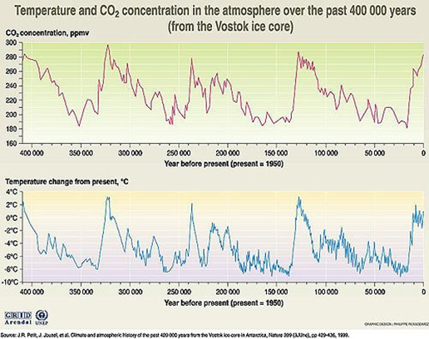

Curiously, the correlation between CO2 concentration and temperature is far weaker over the long history of the earth, although the properties of water and of CO2 do not vary with time. But climate models rely almost exclusively on correlation data. Never mind that the temperature changes came first.

